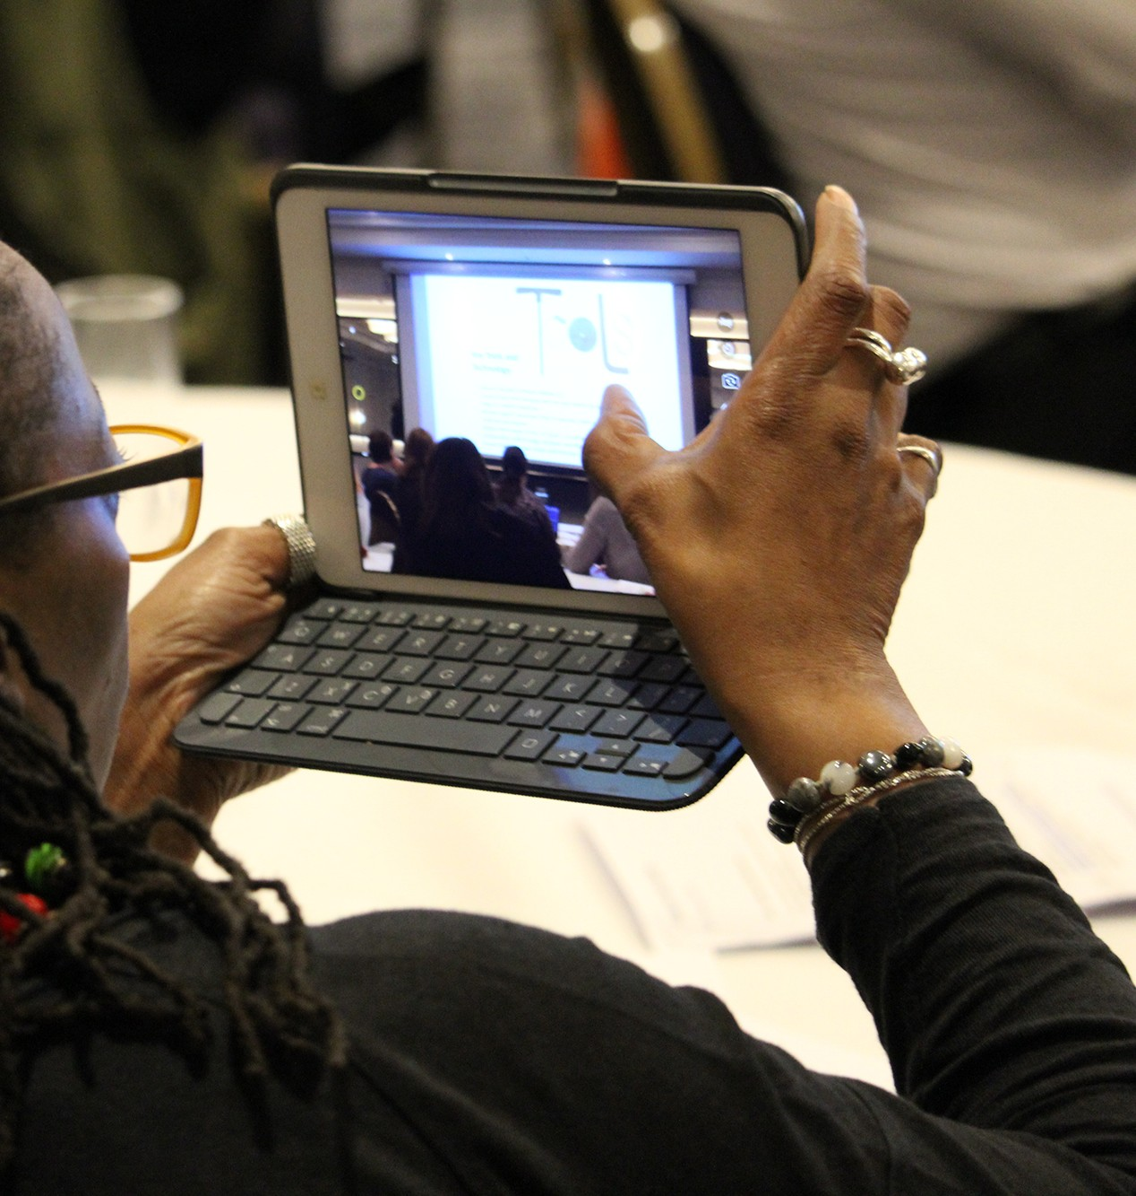

UCISA26 Leadership Summit: Neurodiversity FAQs

This FAQ has been created to make sure every UCISA26 attendee can navigate the Summit with ease and enjoy the event in a way that feels comfortable and inclusive. Inside, you’ll find clear explanations of key neurodiversity concepts along with practical information about accessibility features available throughout the Summit.

We’ve included everything from early registration options, sensory-friendly spaces, quieter areas, communication badges, and alternative ways to engage in sessions, to details on seating options, live captions, and support hosts. You’ll also find guidance on taking breaks, opting out of networking, and who to contact if you need help at any point.

Whether you’re attending with accessibility needs in mind or simply want to feel prepared, this guide is here to ensure everyone has the same opportunity to participate fully and confidently at UCISA26.

Our event has been planned and delivered in alignment with the Neurodiversity in Events checklist.

Contents

What is Neurodiversity? 3
What support will be available to help me navigate UCISA26 easily? 3
Agenda 3
Event Session Materials 4
Help & Accessibility Queries Desk 4
Event Signage 4
Will there be an opportunity for early event registration? 4
What are communication badges? 4
Do you have an Assistance Animals Policy? 5
I intend to bring my assistance animal—what requirements should I be aware of? 5
Should I share any mobility aids I use with the events team ahead of UCISA26? 5
Will there be different seating choices or sensory-friendly options available during the plenary sessions? 5
Will there be a sensory room available at UCISA26 Leadership Summit? 6
What will I find in the sensory room? 6
What is the role of the Sensory Room host? 6
Are there alternative ways to participate in the event sessions? 7
Q&A 7
Live Captions 7
Opt-out Options 7
Session Summaries 7
Is stimming allowed during the event? 7
Can I take breaks during sessions? 7
Can I opt out of networking or social sessions? 8
What should I do if I have any dietary requirements? 8
Who can I contact for support or questions? 8

What is Neurodiversity?
Neurodiversity is an umbrella term for natural variations in how people think and process information. Around 1 in 7 people in the UK are neurodivergent. Many neurodivergent people are highly intelligent and simply experience the world differently.
Common types of neurodiversity include:
- Autism / Autism Spectrum Conditions
- ADHD / ADD
- Dyscalculia
- Dyslexia
- Dyspraxia / Developmental Coordination Disorder (DCD)
Other forms sometimes included under neurodiversity:
- Executive functioning difficulties
- Dysgraphia
- Misophonia
- Slow processing speed
- Stammering
- Tourette’s syndrome
This is not an exhaustive list, and neurodivergence varies by individual. UCISA26 Leadership Summit aims to be inclusive of all neurotypes.

What support will be available to help me navigate UCISA26 easily?
We will provide clear information before and during UCISA26, including agendas, venue details (including a video walk-through), and any important updates. You’ll receive communications in advance, and we’ll also have clear signage and staff on hand throughout the day to help guide you and answer any questions. Our goal is to make the event experience smooth, organised, and easy to navigate for everyone.
Here are the key details on how we’ll support you at UCISA26:

Agenda
The agenda for the UCISA26 Leadership Summit will be available in several locations both before and during the event, including:
- Within the event app (prior to and during the event)
- On the UCISA Portal (prior to and during the event)
- At the registration desk (during the event)
- At the Help & Accessibility Queries Desk (during the event)
- Welcome Pack (during the event)
Please note we will be following the agenda, asking speakers to be strict with timekeeping.

Event Session Materials
If you feel it would be helpful to access any session materials prior to the summit start, such as presentations, please email the team at events@ucisa.ac.uk. We will do our best to accommodate your request; however, please note that there may be some sessions where this may not be possible.
If you also require materials in an alternative format, please get in touch with the event team.

Help & Accessibility Queries Desk
Opposite Registration, you’ll find our Help & Accessibility Queries Desk. Feel free to drop by at any point during the event — a member of Team UCISA will be on hand and happy to assist you.
Foam earplugs will be available from the desk, and several members of our team are trained in neuro-inclusivity should you need additional support.

Event Signage
To help you find your way around the UCISA26 Leadership Summit, you’ll receive a map upon registration, and all rooms will be clearly signposted.
If you do lose your way or would like someone to accompany you through the venue, please visit the Help & Accessibility Queries Desk.

Will there be an opportunity for early event registration?
Yes, we will be offering early registration, with staggered check-in times available to help you avoid queues. If you would like to make use of this, please contact the team at events@ucisa.ac.uk to book your preferred check-in time.

What are communication badges?
After a successful trial and overwhelmingly positive feedback at PACED25, we’re excited to bring our communication badges to the UCISA26 Leadership Summit.
We know events can feel a bit overwhelming, and while many people enjoy being in the middle of the action, others may prefer a little more space. Our badges are designed to help everyone communicate their comfort level with ease:
- Red – Please don’t approach or start a conversation with me
- Amber – I’m open to talking, but I’d like to initiate the conversation
- Green – I’m happy for you to come and chat
If you would like a communication badge, visit our Help & Accessibility Queries Desk or registration desk pick yours up. Simply choose the colour that matches how you’re feeling at the time and attach it to your event lanyard. You can change colours throughout the event.

Do you have an Assistance Animals Policy?
Yes, we do. Our Assistance Animals Policy outlines the support available for delegates who rely on trained assistance animals during our events, including information on venue access, welfare considerations, and how our onsite team can help. To view the full policy, please visit https://www.ucisa.ac.uk/-/media/Files/UCISA/Governance-files/Animal-Assistance-Policy---Jan-2026.pdf, which provides all the details you may need ahead of attending. If you have specific requirements or would like to discuss arrangements in advance, we’re always happy to help.

I intend to bring my assistance animal—what requirements should I be aware of?
If you’re planning to bring an assistance animal, you don’t have to share this with us — but if you feel comfortable doing so, please let our events team know at events@ucisa.ac.uk. This helps us ensure we have the right adjustments in place so you can enjoy the best possible experience at UCISA26.

Should I share any mobility aids I use with the events team ahead of UCISA26?
If you’re planning to use any mobility aids, we would be extremely grateful if you could let our events team know at events@ucisa.ac.uk. This helps us ensure we’ve put the right adjustments in place, including appropriate hotel allocations, so you can have the best possible experience at UCISA26.

Will there be different seating choices or sensory-friendly options available during the plenary sessions?
In the plenary room, we will offer a variety of seating options, including round tables with chairs, beanbag chairs around the sides, and poseur tables at the back for those who may prefer to stand.
Playdough will also be available on every table for you to use as you wish.

Will there be a sensory room available at UCISA26 Leadership Summit?
Yes, at UCISA26, a sensory room will be available. This will be located on the ground floor, next to the registration desk. There will be a host in the room.

What will I find in the sensory room?
Our sensory room offers a supervised, psychologically safe space designed to help you rest, regulate, and recharge. It features dedicated zones for gentle stimulation and relaxation.
- Relaxation Zone
Tactile moon chairs, soft-textured furnishings, and massage cushions.
- Rest Zone
Large flat and sleeper beanbags with soft, comforting textures.
- Low-Stimulation Zone
Mindful activities such as colouring, puzzle books, jigsaws, chess, sudoku, dominoes, playing cards, Uno, and Qwirkle.
You will also find:
- Plant décor and sensory lighting
- Essential oil diffuser with neurodivergent-friendly oils
- Fidget and stim toys
- Weighted blankets
- Noise-cancelling headsets
- Neck pillows and eye masks
- Prayer mat
- Magazines on mental wellbeing and health

What is the role of the Sensory Room host?
The hosts are trained safeguarding and wellbeing professionals who will be able to support delegates throughout UCISA26 Leadership Summit. Their expertise includes Mental Health First Aid, Suicide First Aid, Neurodiversity and Disability Awareness, Safeguarding, and event operations. All Hosts are fully DBS-certified.
The Sensory Room Host is here to:
- Offer immediate reassurance and support if you feel anxious, overwhelmed, or in need of assistance.
- Maintain a calm, quiet environment in our wellbeing and resilience spaces.
- Keep the area clean, refreshed, and comfortable for all delegates.

Are there alternative ways to participate in the event sessions?
You can engage in the summit in various ways and still have a meaningful attendee experience. Participation in any activity is always optional, especially if it feels uncomfortable.
You will find more detail on how we will do this below:

Q&A
We will use both a handheld microphone for Q&A in the main room; and the event app for those who prefer to type their questions or submit them anonymously.

Live Captions
You’ll find a QR code on every table in the plenary room, making it easy to access live captioning on your own device. We shall also display the captions on the main stage screen.

Opt-out Options
You’re welcome to take part in group activities if you’d like, but there’s absolutely no pressure. Feel free to participate in the way that works best for you.

Session Summaries
If you find the session overwhelming and need a break, we will be creating short AI summaries of each event session and will be shared post event.

Is stimming allowed during the event?
Stimming refers to the repeated use of certain movements or sounds. For many people, especially those who are neurodivergent, these actions help with self-regulation and expressing emotions.
Stimming — such as fidgeting, using objects, or pacing — is completely welcome. It’s an important and valid strategy that helps many individuals feel calm and grounded.
If a stim toy would be helpful for you, our Help & Accessibility Desk and Sensory Room will have a variety available — feel free to stop by anytime.

Is there a conference App?
Yes, there is a conference app where you’ll find lots of useful information, including the agenda. You can also use the app to connect with other delegates. If you prefer not to receive direct meeting requests, you can opt out by going to Preferences and turning off Enable Messaging & Meetings.

Can I take breaks during sessions?
Of course — you’re welcome to step out at any time and return whenever you feel ready. Taking a break can be a helpful way to stay focused, manage sensory input, and ease any anxiety.
If the session becomes overwhelming, please don’t worry. We’ll be sharing brief AI-generated summaries after the event, along with a recording and copy of the presentation slides, so you can catch up on anything you miss.

Can I opt out of networking or social sessions?
We understand that networking can feel overwhelming, so there’s no pressure to take part. Please feel free to use the sensory room during this time if that’s more comfortable for you.

What should I do if I have any dietary requirements?
When you booked your ticket to attend the event, you would have been asked to provide any dietary requirements, and these should have been confirmed in your joining instructions.
If these aren’t showing, or you’re unsure whether you’ve already shared them with the team, please contact the UCISA Events Team at events@ucisa.ac.uk or 01865 535 512.
Please note that there will be some quieter seating areas for eating on the ground floor, which you are more than welcome to use if you wish to eat away from the main exhibition room.

Who can I contact for support or questions?
For any support or questions before the event, please contact the UCISA Events Team at events@ucisa.ac.uk or 01865 535 512.
During the UCISA26 Leadership Summit, you can approach any member of the UCISA event team wearing a Sunflower Support badge. Team UCISA will also be easy to spot – just look for the green UCISA lanyards distinguishing them from other attendees.
If you’d like to familiarise yourself with the UCISA team before the event, you can view their photos and profiles on our dedicated page ‘Meet Team UCISA attending UCISA26’.
You’re also very welcome to visit our Help & Accessibility Queries Desk at any time during the event. You’ll find it located opposite the registration area.

